

Marine Scientific Research Application form for UK and Overseas Territories waters

The Ocean Policy Unit of the Foreign Commonwealth and Development Office presents its compliments to the applicant seeking to conduct marine scientific research (MSR) in UK and Overseas Territories waters. In order to receive clearance, please complete the application form below and send to msrapplications@fcdo.gov.uk.

Completed applications, containing all requested information, should be submitted at least six months prior to the proposed start date of the cruise.

Although late applications may be considered, we cannot guarantee that a decision will be made before the proposed start date of the cruise. In the interests of fairness between applications, and to ensure compliance with relevant international obligations, applications will only be expedited in exceptional circumstances, which should be stated and explained as part of the application.

- General Information

1.1.a Cruise name and/or number:
1.1.b Name of Vessel:
1.1.c Flag State of Vessel:
1.1.d Dates of first entry and final departure from the research area by the research vessel and/or other platforms: | Start date: | End date:
1.1.e Port call(s) including dates, if any:

1.2 Particulars of proposed research project:
1.2.a Using the map provided in section 12 of this form as reference, please mark which geographic area(s) the vessel will conduct its research in (mark as many as appropriate)

England |  | Wales |  | Scotland |  |  |  | N. Ireland |  | Overseas Territories
1.2.b If entering the Exclusive Economic Zone/Territorial Sea of any Overseas Territories please state them below:
1.2.c Will any aspect of research involve/impact the seabed, including, but not limited to, dredging, trawling or dragging on the seabed:
Yes |  |  |  |  |  | No
1.2.d Will any of the proposed research take place within Territorial Sea/Internal Waters:
Yes |  |  |  |  |  | No

1.3 Sponsoring Institution(s):
Name:
Address:
Name of Director:

1.4 Scientist in charge of the Project:
Name:
Country:
Affiliation:
Address:
Telephone:
Email:
Website (for CV and photo):

1.5 Entity(ies)/Participant(s) from coastal State involved in the planning of the project:
Name:
Affiliation:
Address:
Telephone:
Fax:
Email:
Website (for CV and photo):

- Description of Project

2.1 Nature and objectives of the project:

2.2 If designated as part of a larger scale project, then provide the name of the project and the Organisation responsible for coordinating the project:

2.3 Relevant previous or future research projects:

2.4 Previous publications relating to the project:

- Geographical Areas

3.1 Please indicate geographical areas in which the project is to be conducted (with reference in Latitude and longitude in decimal degrees, including coordinates of cruise/track/way points/sampling stations). Please provide coordinates in a separate excel spreadsheet.

3.2 Attach chart(s) at an appropriate scale (1 page, high-resolution) showing the geographical Areas of the intended work and, as far as practicable, the location and depth of sampling Stations, the tracks of survey lines, and the locations of installations and equipment.

- Methods and means to be used

4.1 Particulars of vessel
Name: | SONNE
Type/Class: | Research Vessel
Nationality (Flag State): | German (German state service flag)
Identification Number (IMO/Lloyds No.): | IMO-Nr. 9633927
Owner: | Federal Ministry of Education and Research
Operator: | University of Hamburg, Institute for Geology, Bundesstraße 55,  20146 Hamburg
Overall length (metres): | 116 m.
Maximum draught: | 6,40 m
Displacement / Gross Tonnage: | Deadweight 6.844 t / Gross Tonnage 8554 BRZ
Propulsion: | Diesel Electric
Cruising & maximum speed: | Cruising speed: 12 kn  Maximum speed: 15 kn
Call sign: | DBBE
INMARSAT number and method and capability of communication (including emergency frequencies):
Name of Master:
Number of Crew: | Max. 33
Number of Scientists on board: | Max. 40

4.2 Particulars of Aircraft
Name:
Make/Model:
Nationality (flag State):
Website for diagram & Specifications:
Owner:
Operator:
Overall Length (metres):
Propulsion:
Cruising & Maximum speed:
Registration No.:
Call Sign:
Method and capability of communication
(including emergency frequencies):
Name of Pilot:
Number of crew:
Number of scientists on board:
Details of sensor packages:
Other relevant information:

4.3 Particulars of Autonomous Underwater Vehicle (AUV)
Name:
Manufacturer and make/model:
Nationality (Flag State):
Website for diagram & Specifications:
Owner:
Operator:
Overall length (metres):
Displacement/Gross tonnage:
Cruising & Maximum speed:
Range/Endurance:
Method and capability of communication
(including emergency frequencies):
Details of sensor packages:
Other relevant information:

4.4 Other craft in the project, including its use:

4.5 Particulars of methods and full description of scientific instruments to be used (for fishing gear specify type and dimension)
Types of samples and measurements: | Methods to be used: | Instruments to be used: | Carried out within (nm):
Types of samples and measurements: | Methods to be used: | Instruments to be used: | 0 - 12 | 12 - 200 | 200+

4.6 Indicate nature and quantity of substances to be released into the marine environment:

4.7 Indicate whether drilling will be carried out. If yes, please specify:

4.8 Indicate whether explosives will be used. If yes, please specify type and trade name, Chemical content, depth of trade class and stowage, size, depth of detonation, frequency of Detonation, and position in latitude and longitude:

- Installations and Equipment

Details of installations and equipment (including dates of laying, servicing, method and Anticipated timeframe for recover, as far as possible exact locations and depth, and Measurements):

- Port Calls

7.1 Dates and Names of intended ports of call:

7.2 Any special logistical requirements at ports of call:

7.3 Name/Address/Telephone of shipping agent (if available):

- Participation of the representative of the coastal State

8.1 Modalities of the participation of the representative of the coastal State in the research project:

8.2 Proposed dates and ports for embarkation/disembarkation:

- Access to Data, Samples and Research Results

9.1 Expected dates of submission to coastal State of preliminary report, which should include the expected dates of submission of the data and research results:
Short Cruise Report three months after finishing the research cruise

9.2 Anticipated dates of submission to the coastal State of the final report:

9.3 Proposed means for access by coastal State to data (including format) and samples:

9.4 Proposed means to provide coastal State with assessment of data, samples and research results:

9.5 Proposed means to provide assistance in assessment or interpretation of data, samples and research results:

9.6 Proposed means of making results internationally available:

- Other permits submitted

10.1 Indicate other types of coastal state permits anticipated for this research (received or pending):

- List of Supporting Documentation

11.1 List of attachments, such as additional forms/licences and/or permits required by the coastal State:

- Map showing Maritime delimitations of English, Scottish, Northern Ireland and Welsh waters. Please use this map as a reference to answer question 1.2.a. If you are unsure whether your cruise crosses the borders from one administration to another, please ensure you mark BOTH administrations when answering question 1.2.a.

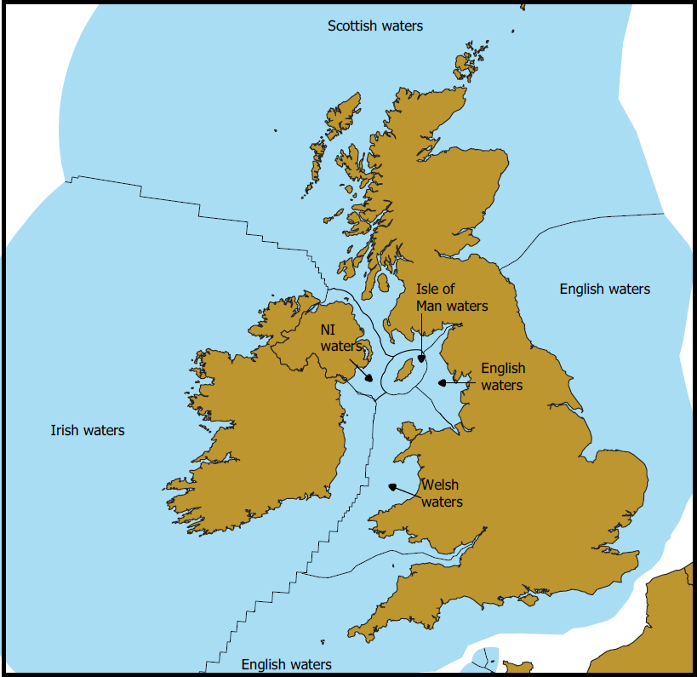

Signature:
Contact information of the focal point:
Name:
Country:
Affiliation:
Address:
Telephone:
Email:
For more information about how we process personal information, please see our Personal Information Charter.

